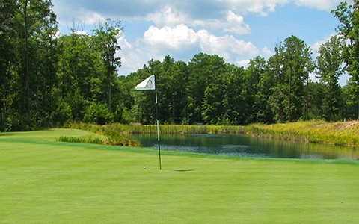
Massaponax Athletics

Golf Tournament

Breakfast Supplied by Southpoint Wawa
Closest to the Pin
Longest Drive
Raffle Prizes
Food and Beverage supplied at various holes
Pre Round Putting Contest
Mulligan Purchase

Information
- Superbowl Sunday
- February 4th, 2018
- Pendleton Golf Club
- $75,00 per person
- $300.00 per foursome

Tournament
1. Captains Choice
2. Shotgun start at 9:30 am
3. Registration begins at 8:00 am .
4. ALL proceeds go to Massaponax Athletics

Checks made out to:
Massaponax High School
ADDRESS:
8201 Jefferson Davis Highway
Fredericksburg, Va 22407
C/O Stan Clements Activities Director
540-710-0419

